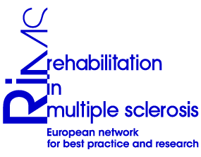
Programme

Joint SIG meeting
Communication, Integration & Participation, Occupation, Neuropsychology

MULTIDISCIPLINARY APPROACH FOR ASSESSMENT AND MANAGEMENT OF COGNITIVE DISORDERS IN PwMS
Melsbroek, Belgium, 18th -19th November 2011

Thursday 17/11/2011
20.00 Welcome reception in hotel

Friday 18/11/2011
9.00 Welcome
9.10 Introduction: situating aims of the meeting, summary of homework, case reports
10.30 Workshop observations and red flags: 4 mixed groups (10-12 persons)
12.30 Lunch

13.30 Workshop content neuropsychological report: 4 mixed groups
16.00 Separate SIG meetings
18.00 End

20.00 Dinner

Saturday 19/11/2011
9.00 Plenary report of workshops of 18/11
10.00 Separate SIG meetings (separate programmes)
12.30 Lunch & goodbye

