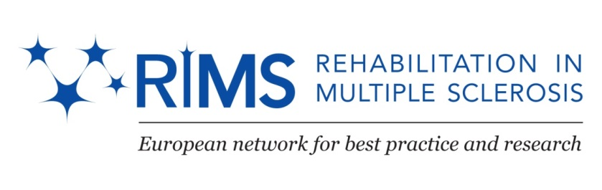

RIMS SIG Occupation meeting

During ECTRIMS/RIMS meeting
Copenhagen (DK) October 4th 2013

Participants

# | Name | E-mail | Function | Organisation | City | Country
1 | Daphne Kos (chair) | Daphne.kos@faber.kuleuven.be; daphne.kos@ap.be | OT | AP University College & KU Leuven & National MS Center | Antwerp & Leuven & Melsbroek | Belgium
2 | Gita Berzina | gita.berzina@gmail.com | MD | Rehabilitation centre Jaunkemeri | Jurmala | Latvia
3 | Inge Gjerrild Søegaard | igs@sclerosecentret.dk | Head Rehabilitation | MS Centre Ry | Ry | Denmark
4 | Inger Grethe Løyning | IngerGrethe.Loyning@mssenteret.no | OT | MS Senteret Hakadal | Oslo | Norway
5 | Jelka Jansa | jelka.jansa@kclj.si | OT | University Medical Center Ljubljana | Ljubljana | Slovenia
6 | Jytte Jakobson | jrja@sclerosecentret.dk | OT | Sclerosecenter Haslev | Haslev | Denmark
7 | Kallmeyer Lene | lkam@sclerosecentret.dk | OT | Sclerosecenter Ry | Ry | Denmark
8 | Laureys leen | leen.laureys@mscenter.be | OT | National MS Center Melsbroek | Melsbroek | Belgium
9 | Marcia Finlayson | marcia.finlayson@queensu.ca | OT | Queen’s University Kingston | Ontario | Canada
10 | Marijke Duportail | marijke.duportail@mscenter.be | OT | National MS Center Melsbroek | Melsbroek | Belgium
11 | Mónica Gotsens | mgotsens@fem.es | OT |  |  | Spain
12 | Núria Fillo Papiol | nfillo@fem.es | OT | CemCat | Barcelona | Spain
13 | Zorana Sicherl | zorana.sicherl@kclj.si | OT | University Medical Center Ljubljana | Ljubljana | Slovenia

Agenda

- Meeting RIMS Brighton 2014 + next in-between SIG Occupation meeting
- AMPS study: update – Jelka Jansa & Daphne Kos
- Multicenter study arm function – Ilse Lamers

RIMS Meeting Brighton 2014 + next in-between SIG Occupation meeting

Next RIMS meeting will take place in Brighton (UK) on June 5-7 2014.
Theme: “Supporting Behaviour Change. Linking science to practice”
Contributions of SIG Occupation:
- Variability of ADL performance in people with MS
- Using tele-rehab to support behaviour change
- Implementation of Cognitive Disabilities Model into MS rehabilitation – Joke Raats

There will be a time slot of 1,5 hour for SIG Occupation meeting.

Next in-between meeting will be organized in autumn 2014. Núria invites us to the new day center of Barcelona, but will confirm this later on this year. Núria and Daphne will make arrangements on exact date and location.

Theme/contributions? brainstorm:
- COPM / occupational performance
- Multicenter arm study
- Putting science into practice
  - How to communicate with your clients about scientific research?
  - Evidence based practice
- How to use assessment in OT practice relates to OT process models

Conclusion: theme will be related to implementing science into (OT) practice; exact name to be decided
Possible contributions:
- OT practice model – update and link to EBP (Jelka, Daphne, Joke, others?)
- UK group of Susan Michie – changing behavior of therapists (in implementing science into practice) – maybe already present in Brighton (Daphne will inform)
- Change the changers (Tarja?)
- Experiences with implementing science into practice + barriers/facilitators

In Brighton meeting we can already attend general lectures on this topic, so we will be able to translate/apply to our own practice.

AMPS study: update – Jelka Jansa & Daphne Kos

Daphne presents outline of this multicentre study:

Title: Variability of activities of daily living performance in people with multiple sclerosis: a multicenter study
Objective :
To describe the variability in persons' ADL motor and ADL process skills at different EDSS stages.

Participating centers:
- National MS Centre Melsbroek (Belgium)
- University Medical Centre Ljubljana (Slovenia)
- The Multiple Sclerosis Hospital Haslev (Denmark)
- The Multiple Sclerosis Hospital Ry (Denmark)
- MS-Senteret Hakadal (Norway)
- MS Center Masku (Finland)
- Rehabilitation center De Mick Brasschaat (Belgium)
---------------
Coordinator:
Daphne Kos, KU Leuven & Artesis University College of Antwerp (Belgium)
Jelka Jansa, University Medical Centre Ljubljana (Slovenia)

Where are we now?
- N=175
- Data collection until December 15
- Presentation during RIMS 2014
- Publication in 2014

Poster will be presented during ECTRIMS conference (Poster # 1349)
Multicentre study of exploring variability of activities of daily living performance in people with multiple sclerosis
J. Jansa, S. Ferdinand, M. Milo, I.G Loyning, T. Huilla, J. Jakobsen, L. Kallmayer, S. Ilsbroukx, N. Fillo, D. Kos , on behalf of the RIMS, SIG OCCUPATION
Poster Session "Comprehensive care and rehabilitation"
Friday, 4 October 2013 between 15:30h and 17:00h.

Multicenter study arm function – Ilse Lamers

Ilse Lamers and Peter Feys (Hasselt, B) shortly informed the group concerning the upcoming multicenter trial on arm function and invites therapists/centers to participate. For more information or consent to participate, please contact Ilse Lamers (ilse.lamers@uhasselt.be).

