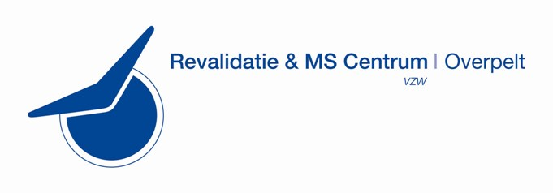

In between meeting:
Special Interest Group (SIG) on Communication and Swallowing
‘Innovative strategies of assessment and rehabilitation’

Overpelt, Belgium

Local Organizers: Ingrid Theunkens (BE), Kelly Van Landeghem (BE)
Chair and Co-Chair SIG Swallow: Leonie Ruhaak (NL) and Francesca De Biagi (I)
RIMS Chair: Vincent de Groot (NL)

Accommodation: Hotel, de Secretaris, dorpsstraat 60 – 3900 Overpelt
Program Meeting
Thursday November 16th

From 18.00 – Welcome Diner

Friday November 17th Meeting Venue: Rehabilitation and MS centre,
Boemerangstraat 2, 3900 Overpelt

08.30-09.00 Registration

09.00-09.10 Welcome
Heidi Jannis

09.10-09.40 Session 1: DYMUS RIMS Grant Project: Update
Leonie Ruhaak

09.40-10.00 Coffee Break

10.00-11.00 Session 2: Screeningtool Dysphagia in MS (to be confirmed)
Astero Constantinou

11.00-11.45 Session 3: Research Tongue Strength in MS
Karen van Leuven
Elien Verbeke

11.45-12.30 Guided Tour in Revalidation and MS Centre Overpelt
Ingrid Theunkens
Kelly Van Landeghem

12.30-13.30 Lunch

13.30-15.00 Session 4: Revalidation of Swallowing in MS
Gwen Van Nuffelen

15.00-15.30 Coffee Break

15.30-16.30 Session 5: Discussion on Telepractice in MS (to be confirmed/skype)
Marta Renom

19.30 Diner in Hasselt

Saturday November 18th Meeting Venue: Rehabilitation and MS centre,
Boemerangstraat 2, 3900 Overpelt

08.30-09.00 Session 1: Systematic Review RIMS Grant Project: Update
Leonie Ruhaak

09.00-10.00 Session 2: Augmentative Communication in MS

10.00-10.15 Coffee Break

10.15.11.00 Testprotocol patiënts with MS/grouptherapy in Revalidation and MS Centre
Case study
Ingrid Theunkens
Kelly Van Landeghem

11.00-12.00 SIG future plans and goals
Leonie Ruhaak

12.00-12.45 Lunch

12.45-14.30 It’s a fair: market lead technology talk/demo’s and practical
tries with workshops material

14.30-14.45 Goodbye note

Registration

RIMS members: free
Non-RIMS members: 80 euros

Registration includes:
- Attendance
- Coffee breaks and lunches
- Joint dinner on Friday (for RIMS members only)
- Accommodation (for RIMS members only)
- Certificate of attendance

