Registration form SIG Communication and swallowing meeting Overpelt 2017
Conference Information

Conference: SIG Communication and swallowing in-between meeting 2017, 17th – 18th November, Overpelt (BE)
Topic: Innovative strategies of assessment and rehabilitation
Location: Rehabilitation & MS Centre Overpelt
Location address: Boemerangstraat 2, 3900 Overpelt, Belgium
Start date: 17/11/2017
End date: 18/11/2017

Conference Registration

First name & surname:(*)
Email:(*)

Address(*)

Centre(*)

Zipcode(*)

City(*)

Country(*)

Rims Member?(*)
Yes
Membership number:

No

Occupation(*)

First time SIG meeting?(*)
Yes
No

Hotel Information

Hotel, de Secretaris, dorpsstraat 60 – 3900 Overpelt

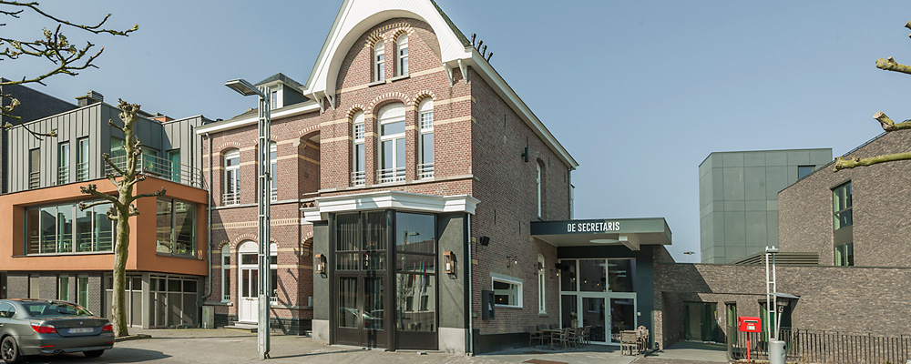
Price per night single room: 85,00€
Price per night double room: 110,00€
Prices are per room, per night, city tax & breakfast included.

Hotel Booking Information

Dates you wish to stay(*)

Thursday 16th (to be paid by delegates upon checkout)

Friday 17th (free for RIMS members)

Saturday 18th (to be paid by delegates upon checkout)

The night from Friday 17th on Saturday 18th will be free for RIMS members if booked before the registration deadline which is the 25th of September. We strongly recommend to meet this deadline, as room availability cannot be guaranteed after this deadline. However, for those RIMS members booking after 25th of September; the night will only be reimbursed if staying in Hotel De Secretaris up to 110,00€.

Welcome drinks & dinner

Events you wish to attend(*)

Welcome dinner on Thursday 16th at 6 pm
Networking dinner (buffet + drinks) on Friday 17th in Hasselt city centre - The Boulevard”, Kattegatstraat 1, Hasselt (Free for RIMS-members, taxi is included – Non-RIMS Members pay € 52)

Tickets

To complete the registration form you will now have to select a ticket according to your choices above. Select a ticket from the dropdown menu below. Even RIMS members need to select a ticket (FREE) to complete the registration.

Non-RIMS Members – Both days - € 80
RIMS Members – Both days – FREE
Non-RIMS Members – One day - € 40
Friday
Saturday
RIMS Members – One day – FREE
Friday
Saturday

Payment

When you completed this form you can send it to directie.secretariaat@msreva.be
You will receive an email containing the payment and hotel information

