Report SIG in-between meeting
SIG group | Psychology and Neuropsychology
Date of in-between meeting | 05th of December 2020
Venue (incl. city, country) | online
Topic | Mindfulness, Covid-19 and future plans
Report (max. 1750 characters):
Topics of the meeting
- Welcome and general information
- Exchange and talk about COVID-19 and its relation to our clinical work
- Case studies
- Update and first results of the Comp-ACT Project (Ambra)
- Organisational aspects/next inbetween meeting
- Conclusion and perspectives
1: A mindful exercise – operated by Ambra
Ambra picked us up and transfered us to a wonderful journey into self-reflection and personal selfcare
2: Exchange and talk about COVID-19 and its relation to our clinical work
What are your personal / professional experiences at the moment with the Covid-19 pandemic?
- Most of us experienced a big impact and burden of COVID-19 aspects in our clinical work.
- We discussed the influences and possible ways to coping with the burden
3: Case studies
a. Julia presented a case (positive thinking and dysfunctional reflection and behavior of the objective current situation in clinical sence)
4: Update and first results of the Comp-ACT Project (Ambra) – postponed because more time for discussion regarding the current situation with clinical and personal challenges was needed
5: Organisational aspects/next inbetween meeting
a. Election of a new SIG chair at the next inbetween meeting i. I was elected for an executive board member of RIMS and would like to overhand this position – WHO WANT TO BECOME THE NEXT SIG CHAIR?
- Anita would like to be the Co-chair (as in the past)
- Please let me know if you are interested
b. Next inbetween meeting
- We decided to have another online meeting in spring 2021
- I will organize this meeting and will start a doodle to find a date
6. Conclusion and perspectives

Pictures:
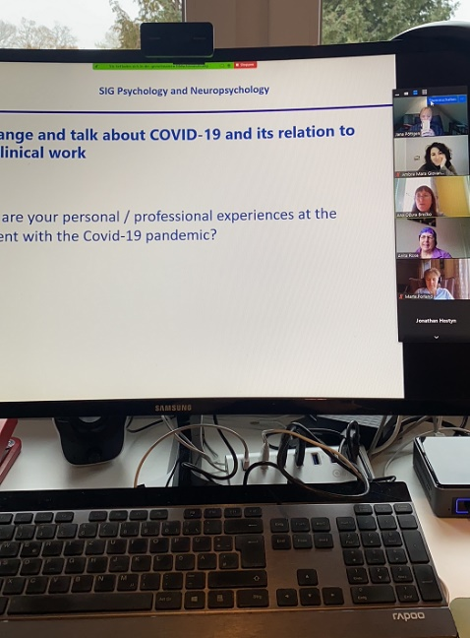
Group picture (incl. first and last names):

Participant list:
First Name | Last Name | Country
Marte | Forland | Norway
Ana | Ožura Brečko | Slovenia
Julia | Segal | United Kingdom
Gaetano | Perrotta | Belgium
Jolien | Steyaert | Belgium
Jana | Poettgen | Germany
Ana Maria | Canzonieri | Spain
Mieke | D'hooghe | Belgium
Michelle | Pirard | Belgium
Blanca | De Dios Perez | United Kingdom
Sara | Navarro Gómez | Spain
Mònica | Nieves Collado | Spain
Lourdes | Assens Tauste | Spain
Anita | Rose | United Kingdom
Sarah | Thomas | United Kingdom
Karen | Turpin | Canada
Kris | Van Der Wegen | Netherlands
Melloney | Schenk | Netherlands
Jan | Holmberg | Finland
Ambra Mara | Giovannetti | Italy
Tinne | De Strooper | Belgium
Menno | Schoonheim | Netherlands

Future plans: Election of a new SIG chair
Next in-between meeting: Online inbetween meeting is planned for spring 2021

