Report SIG in-between meeting
SIG group | Occupation
Date of in-between meeting | Did not have in-between meeting in 2020
Venue (incl. city, country)
Topic

Report (max. 1750 characters):
SIG Occupation started 2020 with planning of an in-between meeting hosted at Masku Neurological rehabilitation center. Unfortunately, the COVID-19 pandemic stopped us from arranging the event.
Our group has therefore only had one meeting this year, during the annual RIMS conference digitally on December 5th. We were happy to have a large number of participants to our digital meeting. The program was a combination of invited research presentations and interactivity discussing and sharing our clinical practice during the pandemic. Thank you for all contributors. This year, as previous years, we had participants joining our group for the first time. We are happy to increase our network and hope for possibilities to meet in person in 2021. We will plan for an in-between meeting late fall of 2021 and we will of course have a meeting during the annual RIMS conference.

Pictures: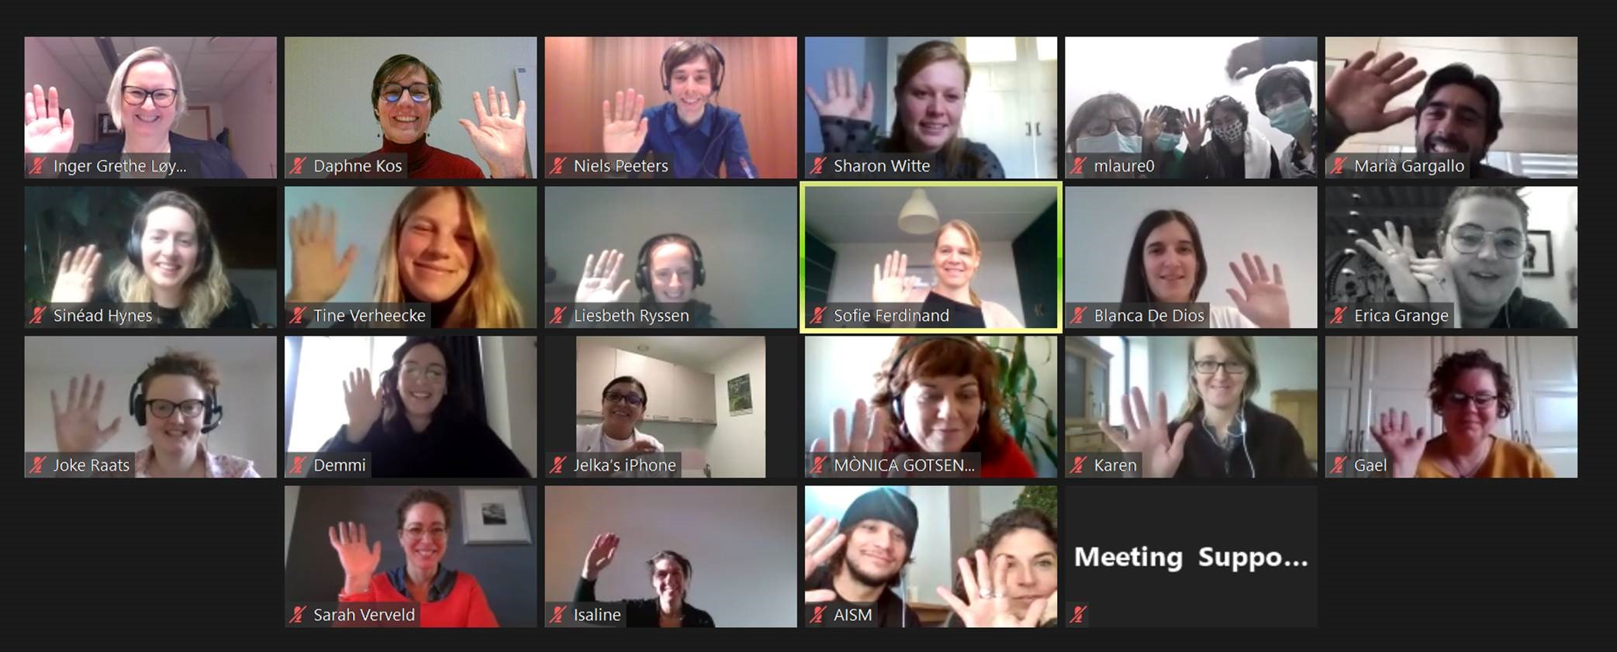
Group picture (incl. first and last names):

Participant list:
First Name | Last Name | Country
Jelka | Jansa | Slovenia
Isaline | Eijssen | Netherlands
Liesbeth | Ryssen | Belgium
Lene | Moeller | Denmark
Inger | Løyning | Norway
Tine | Verheecke | Belgium
Heidi | Van Casteren | Belgium
Meta | Milo | Belgium
Leen | Laureys | Belgium
Nicky | Vandebroucke | Belgium
Ann | Van Loock | Belgium
Marleen | Van Den Eynde | Belgium
Demmi | Janssen | Belgium
Mònica | Gotsens Anguera | Spain
Marià | Gargallo Noval | Spain
Erica | Grange | Italy
Judy | Cornish | United Kingdom
Sinéad | Hynes | Ireland
Niels | Peeters | Belgium
Sofie | Ferdinand | Belgium
Valeria | Bergamaschi | Italy
Maria | Chekmeneva | Russia
Daphne | Kos | Belgium
Samantha | Turner | United Kingdom
Sharon | Witte | Netherlands
Sarah | Verveld | Netherlands
Joke | Raats | Belgium

Future plans: short meeting during the annual RIMS conference and 1 ½ day in-between meeting late fall 2021
Next in-between meeting: venue to be confirmed

